Lesson plan (Six thinking hats)

Topic
Technology & Future

Subject & class
English, 3rd grade (upper-intermediate)

Aims
- To discuss and predict the future of life on Earth and in space
- To discuss and predict the possibility of living on other planets (e.g. Mars)
- To revise the conditionals and future tenses (future simple, continuous and future perfect tense).
- to role-play a character type while having a discussion

Materials
tablets, smatphones, six thinking hat role cards

Outcomes
Students will discuss the future (benefits and problems) of life on Earth and in space.

Students will be able to role-play a character type while having a discussion using a Six thinking hats method.

Procedure(90minutes)
1. Warmer (15 minutes) | T gives example sentences for revision of future tenses:  ˝By year 2100, people_____ be _____ on vacation to Mars.(go)˝  ˝By year 2160, the polar ice-caps _______ have _______.(melt)˝  T asks Ss to discuss the possibility of the life on Mars.  T explains the Six thinking Hats method to Ss. In the 1980s Edward de Bono came up with his Six Thinking Hats idea, in which businessmen use a parallel thinking process which helps them become “more productive, focused, and mindfully involved”.  Class is divided into 4 groups (six Ss per group).  The question is: ˝ Should people form colonies on Mars?˝  Each group gets a text:  ‘NASA and many other international space agencies and governments  intend to cooperate to send humans to the Moon to live, conduct  experiments and help plan for other missions to Mars and beyond.  Sending humans to the Moon offers a great opportunity for advances in  science and technology. However, many argue that the amount of money  required for this project would be much better spent on sustainable  technology here on Earth, to combat issues such as water shortages,  poverty and climate issues.  The Australian Government has been asked to join this group and provide  money and research to help send humans to the Moon. It is your group’s  job to advise the government:  Should we send people to live on the Moon, or should we spend the  money on much needed projects on Earth?’
2. Main part  (50 minutes) | Each Ss gets a role card. Each group should have at least one member with a different coloured hat.  T explains the role of each hat. Ss write down all the information they need to research to  make a decision. Ss can use websites for their research:  (https://www.nasa.gov/centers/hq/library/find/bibliographies/space_colonization  https://www.space.com/how-feed-one-million-mars-colonists.html)  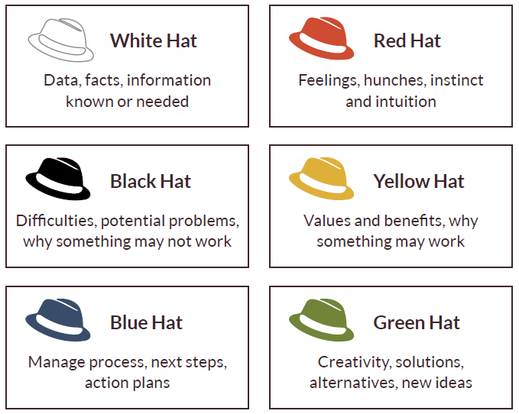  Starting with the White hat, groups spend the time (White Hat: 10 min, Red Hat: 5 min, Black, Yellow, Green and Blue Hats 5 min) brainstorming,  discussing and writing down notes under each hat on the worksheet. The  teacher keeps time, and encourage groups to stay focused on the  particular hat.  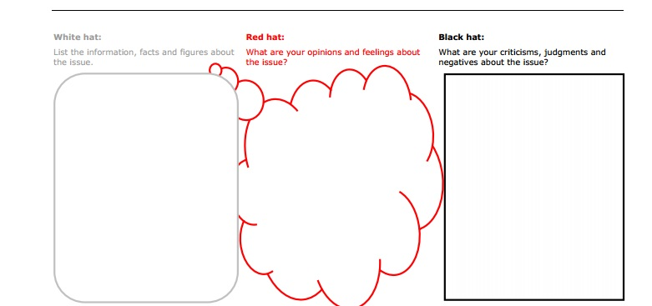  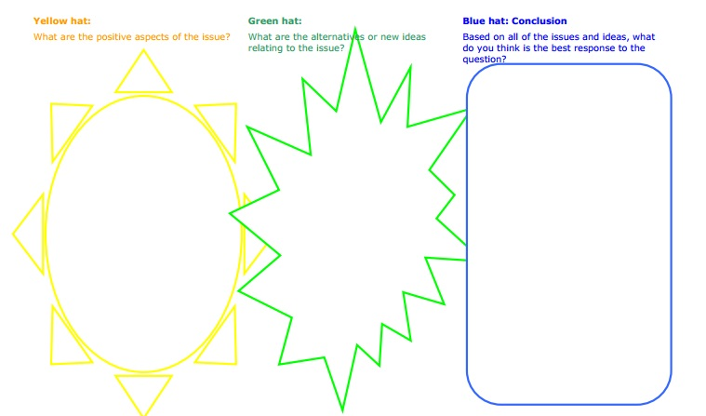
3. Conclusion  (25 minutes) | After the students have worked through the six-hats, each group presents  their findings (Blue Hat) to the rest of the class.  Ss discuss whether the thinking hats process changed their mind about the  topic  Self-assessment  https://www.mentimeter.com/s/7c9837ae5798c6680fa2821f477f0239/523be7cdbe47

